**Software Requirements Specification**

**for**

Life Habitat

**Version 2.3 approved**

**Prepared by**

**PM:** Brianna Gannett

**Designer:** RoisinRumsey

**Developers:** Sarah Turmel

Dean Hauser

Emily Scott

**Team Ethernet**

**10/7/2024**

**Table of Contents**

**Table of Contents ii**

**Revision History ii**

**1. Introduction 1**

1.1 Purpose 1

1.2 Document Conventions 1

1.3 Intended Audience and Reading Suggestions 1

1.4 Product Scope 1

1.5 References 1

**2. Overall Description 2**

2.1 Product Perspective 2

2.2 Product Functions 2

2.3 User Classes and Characteristics 2

2.4 Operating Environment 2

2.5 Design and Implementation Constraints 2

2.6 User Documentation 2

2.7 Assumptions and Dependencies 3

**3. External Interface Requirements 3**

3.1 User Interfaces 3

3.2 Hardware Interfaces 3

3.3 Software Interfaces 3

3.4 Communications Interfaces 3

**4. System Features 4**

4.1 System Feature 1 4

4.2 System Feature 2 (and so on) 4

**5. Other Nonfunctional Requirements 4**

5.1 Performance Requirements 4

5.2 Safety Requirements 5

5.3 Security Requirements 5

5.4 Software Quality Attributes 5

5.5 Business Rules 5

**6. Other Requirements 5**

**Appendix A: Glossary 5**

**Appendix B: Analysis Models 5**

**Appendix C: To Be Determined List 6**

**Revision History**

| **Name** | **Date** | **Reason For Changes** | **Version** |
| --- | --- | --- | --- |
| Sarah Turmel | 10/8/24 | Filling in features and descriptions of features | 1.1 |
| Emily Scott | 10/9/24 | Filled in Main Page | 1.2 |
| Roisin Rumsey | 10/9/24 | Brought ½ Functional Reqs. from reqs. Doc. | 1.3 |
| Dean Hauser | 10/9/24 | Brought ½ Functional Reqs. from reqs. Doc. | 1.3 |
| Sarah Turmel | 10/9/24 | Brought ½ NonFunc. Reqs. from reqs. Doc | 1.4 |
| Brianna Gannett | 10/9/24 | Brought ½ NonFunc. Reqs. from reqs. Doc | 1.4 |
| Brianna Gannett | 10/9/24 | Added UI Mockups To Section 3.1 | 1.5 |
| Emily Scott | 10/16/24 | Completed Section 2 | 2.0 |
| Dean Hauser | 10/16/24 | Completed Section 1 | 2.1 |
| Dean Hauser | 10/20/24 | Addressed feedback from Dr. Greg | 2.2 |
| Roisin Rumsey | 10/20/24 | Added new UI Mockups to Section 3.1 | 2.3 |

# **Introduction**

## **Purpose**

*This document is a comprehensive requirements specification for the first release of Life Habitat. It contains detailed information for various systems, including task creation, avatar creation, and goal tracking.*

## **Document Conventions**

*This Document was created based on the IEEE template for System Requirements Specification Documents.*

*The following conventions in the document were used as follows:*

| **Convention** | **Description** |
| --- | --- |
| HTTP | Hypertext Transfer Protocol |

## **Intended Audience and Reading Suggestions**

*This document, organized by system requirements, follows a logical order from User creations to Performance requirements. It is intended for the product manager, developers, designers, and users, providing a structured overview of the Life Habitat software.*

## **Product Scope**

*Life Habitat is goal-tracking Tamagotchi-like software that allows users to visualize their goal process by seeing their avatars' health. The more goals you do, the better your avatar's health will be. This software aims to motivate users to do their boring and tedious tasks with a game and reward system integrated into it.*

## **References**

*Life Habitat Team Github Link:* [*https://github.com/COS420-Fall24/Team-E*](https://github.com/COS420-Fall24/Team-E)

# **Overall Description**

## **Product Perspective**

*Life Habitat is an application that is designed to help people focus on completing daily tasks that might seem tedious and sometimes get left behind. Life Habitat is meant to take over for normal calendar apps and other similar applications by focusing on a more emotional connection to its features and always providing positive feedback, instead of relying on punishment to keep the users on track.*

## **Product Function**s

**Homepage/Login Page**

*· Welcomes User*

*· Has link to registration page*

*· Allows users to login*

**Registration Page**

*· Allows user registration*

**Main Page View**

*· Shows user avatar*

*· Shows avatar statistics*

*· Shows user notifications*

*· Shows short list of upcoming tasks*

*· Shows task history*

*· Links to all other pages*

**Task Page**

*· Lists tasks set for the day*

*· Shows upcoming tasks for the week/month*

*· Shows user progress*

*· Allows users to create tasks*

*· Allows users to edit tasks*

*· Allows users to delete tasks*

*· Allows users to mark tasks as completed*

**Avatar Page**

*· Allows users to edit avatar*

*· Allows users to buy accessories for the avatar with points*

## **User Classes and Characteristics**

*Life Habitat is created using the React app, CSS, HTML, and Typescript.*

## **Operating Environment**

*Life Habitat will operate on all major operating systems including Windows 10/11, Mac OS, Android, Linux, etc.*

## **Design and Implementation Constraints**

*Life Habitat will contain security systems to protect user data. This is because users will be giving their personal information for the full functionality of the app. For example, a task might list the date and time of a doctor's appointment, or when the user will be out of the house getting groceries. These could put the user at risk if it was released to third parties.*

# **External Interface Requirements**

## **User Interfaces**

This is an example of the Life Habitat Sign In page. Clicking the Register button at the top of the page will allow the user to create an account if they do not already have one. Clicking Forgot Password will allow the user to send an email to the email address associated with their account to create a new password.

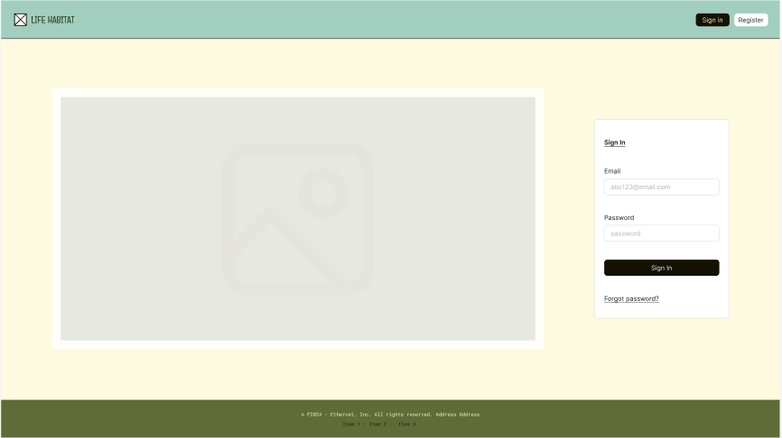

This is an example of Life Habitat’s Task Page. From this page you can view your current open tasks and see upcoming tasks on the right. You can mark tasks as completed by pressing the ‘Done’ button under their title and description.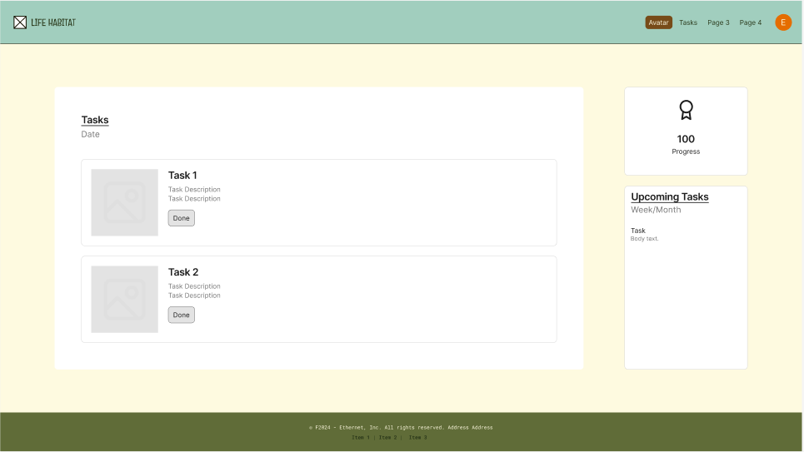

This is an example of the overlay that would appear for a user to create a new task, with the additional recurrence and reminder settings overlays.

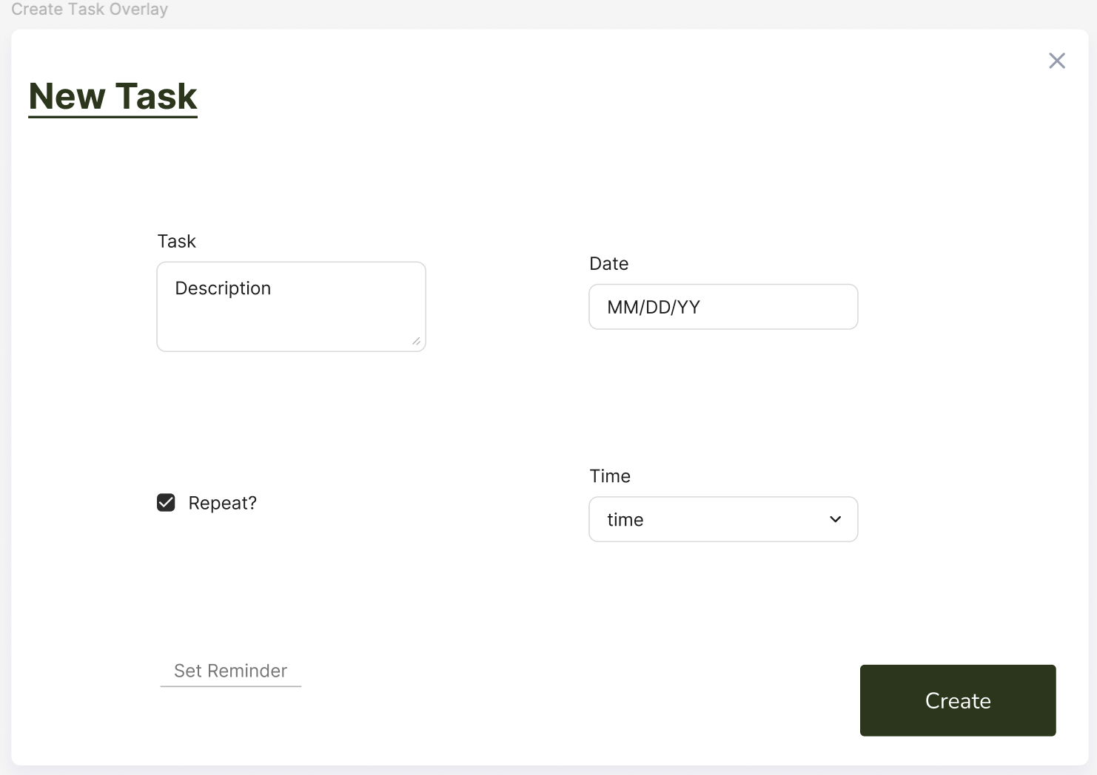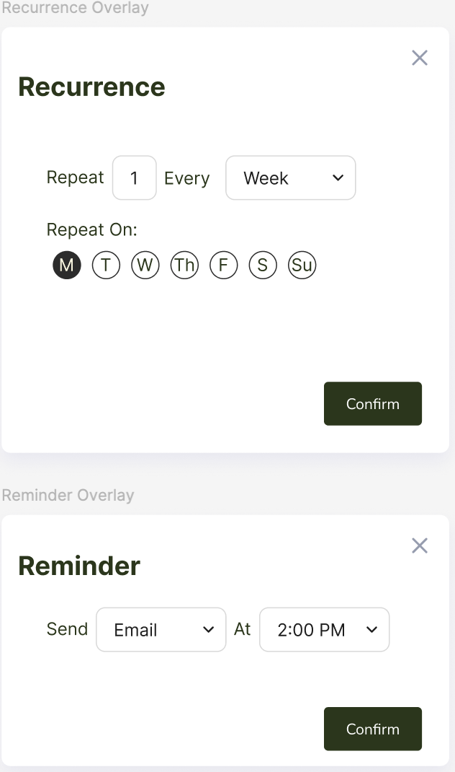

This is an example of the flow for creating tasks. The user hits the New Task button to open the Create Task Overlay, user then fills in appropriate data, and hits the Create button to have the new task appear under the Tasks view.

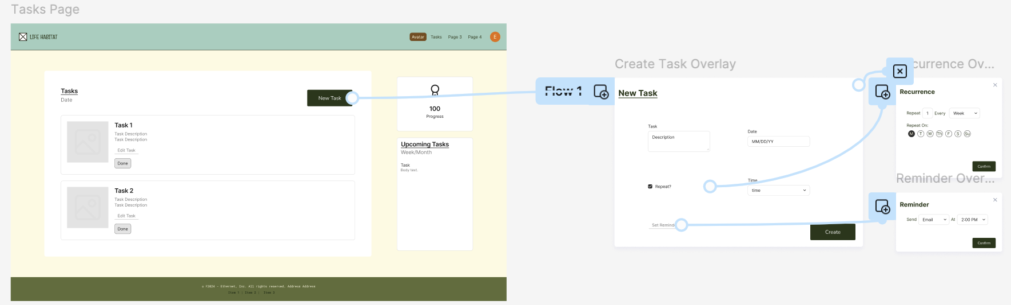

This is an example of the avatar Page. On this page you can see the avatar (where the gray box currently appears on the left) and its details. You can also preview upcoming tasks and see the history of tasks you have completed.

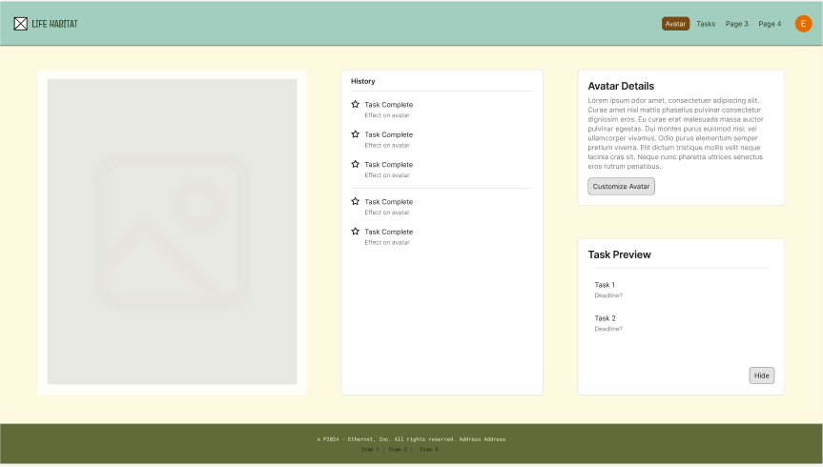

This is an example of the Customize Avatar Page which is reached through the Customize Avatar Button on the Avatar Page. This page allows users to change certain aspects of their Avatar so it better represents the user’s Self. Drop down menus will likely include things like Eye Color, Hair Color, etc.

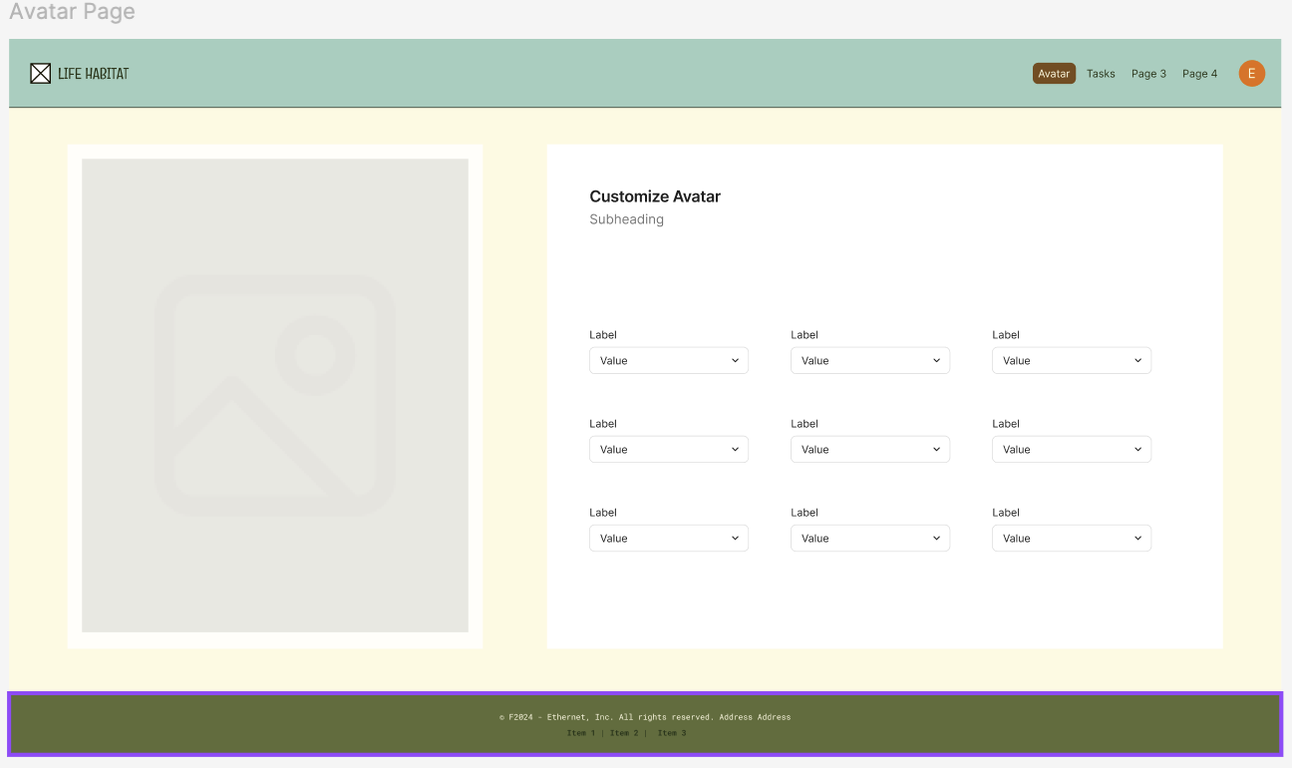

This is an example of the Sleep Tracking Page, where users can log sleep data by manualing inputting what times they went to bed and woke up, or they can choose to upload more detailed data collected from other devices.

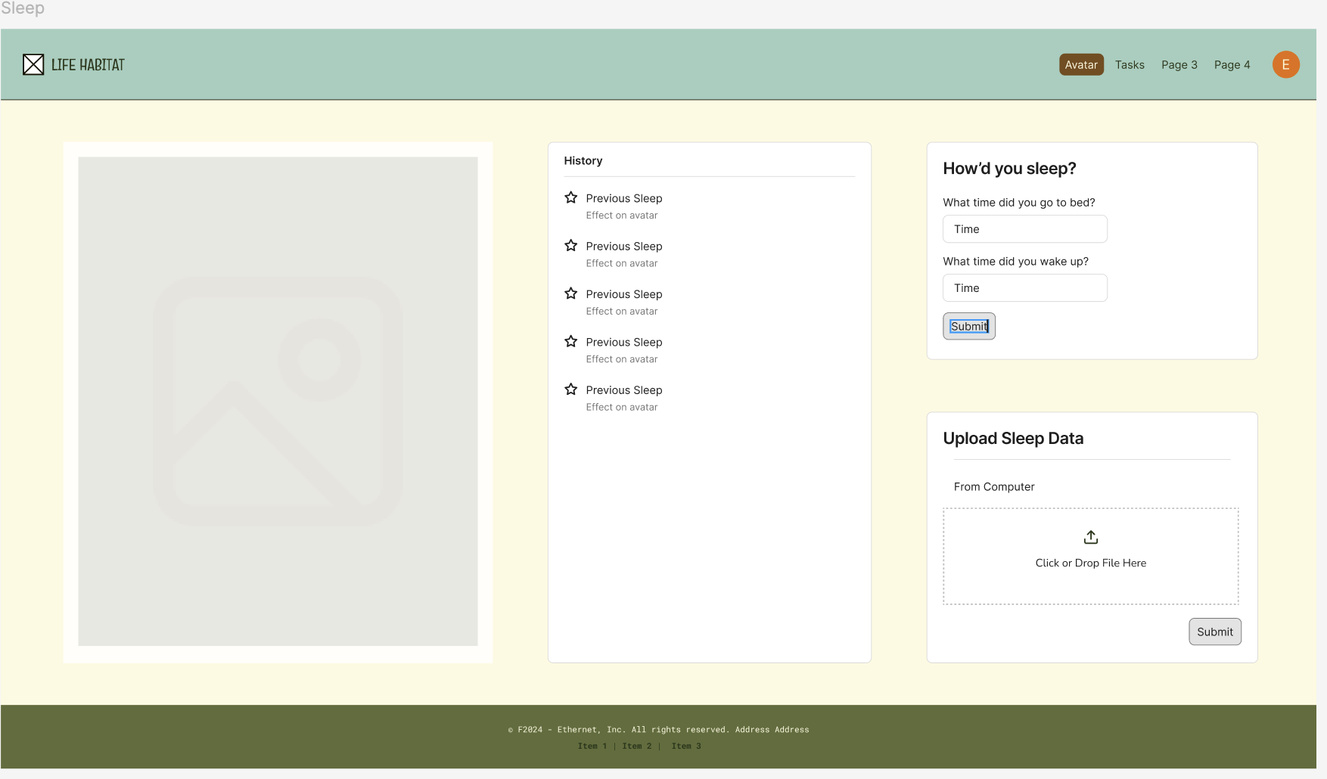

## **Hardware Interfaces**

*<Describe the logical and physical characteristics of each interface between the software product and the hardware components of the system. This may include the supported device types, the nature of the data and control interactions between the software and the hardware, and communication protocols to be used.>*

## **Software Interfaces**

*<Describe the connections between this product and other specific software components (name and version), including databases, operating systems, tools, libraries, and integrated commercial components. Identify the data items or messages coming into the system and going out and describe the purpose of each. Describe the services needed and the nature of communications. Refer to documents that describe detailed application programming interface protocols. Identify data that will be shared across software components. If the data sharing mechanism must be implemented in a specific way (for example, use of a global data area in a multitasking operating system), specify this as an implementation constraint.>*

## **Communications Interfaces**

*<Describe the requirements associated with any communications functions required by this product, including e-mail, web browser, network server communications protocols, electronic forms, and so on. Define any pertinent message formatting. Identify any communication standards that will be used, such as FTP or HTTP. Specify any communication security or encryption issues, data transfer rates, and synchronization mechanisms.>*

# **System Features**

*<This template illustrates organizing the functional requirements for the product by system features, the major services provided by the product. You may prefer to organize this section by use case, mode of operation, user class, object class, functional hierarchy, or combinations of these, whatever makes the most logical sense for your product.>*

## Tasks

4.1.1 Description and Priority

This feature will allow the user to create and modify tasks with different characteristics and to satisfy different needs. Users will be able to specify what a task is for, whether or not it repeats, and more. This feature is High Priority.

4.1.2 Stimulus/Response Sequences

*<NOT FOR DELIVERABLE 1>*

*<List the sequences of user actions and system responses that stimulate the behavior defined for this feature. These will correspond to the dialog elements associated with use cases.>*

4.1.3 Functional Requirements

FREQ-1.1: The system shall track user-created tasks.

FREQ-1.2: The system shall provide a space for the user to enter a description of each task.

FREQ-1.3: The system shall repeat daily or weekly tasks accordingly.

FREQ-1.4: The system shall allow users to get task recommendations through AI generation.

FREQ-1.5: The system shall request to send the user push notifications for task reminders

FREQ-1.6: The system shall allow users to update prior created tasks and goals with new info.

FREQ-1.7: The system shall recommend new healthy habits to the task list once a user has successfully completed previous repeated tasks three times in a row.

## User Encouragement

4.2.1 Description and Priority

This feature will provide the user with encouragement to complete or after completion of their tasks and a friendly atmosphere. Users will receive notifications as often as specified to complete a task and positive feedback on their progress. This feature is High Priority.

4.2.2 Stimulus/Response Sequences

*<NOT FOR DELIVERABLE 1>*

*<List the sequences of user actions and system responses that stimulate the behavior defined for this feature. These will correspond to the dialog elements associated with use cases.>*

4.2.3 Functional Requirements

FREQ-2.1: The system shall have the avatar provide additional encouragement when the user fails to complete a task.

FREQ-2.2: The system shall provide encouraging feedback to the user by sending motivational messages when a task is failed.

FREQ-2.3: The system shall reward users for completing tasks without using reminders and notifications if set by a user by providing achievements or points when a task is marked completed by the user.

FREQ-2.4: The system shall motivate the user to build positive habits with a customizable avatar that reflects the user’s progress and habits.

## Avatar

4.3.1 Description and Priority

The application will include a customizable avatar to reflect the user’s habits in caring for themself. Failing to complete tasks will lead to a more disgruntled appearance, whereas being timely and making progress will lead to an improvement in the avatar’s health. This feature is High Priority.

4.3.2 Stimulus/Response Sequences

*<NOT FOR DELIVERABLE 1>*

*<List the sequences of user actions and system responses that stimulate the behavior defined for this feature. These will correspond to the dialog elements associated with use cases.>*

4.3.3 Functional Requirements

FREQ-3.1: The system shall allow users to customize their avatars with any unlocked rewards.

FREQ-3.2: The system shall allow the user to set or not set reminders and notifications for any created tasks.

FREQ-3.3: The system shall allow the user to buy avatar skins with their achievement points.

## Account

4.4.1 Description and Priority

The application will require that users create accounts. This will allow for the system to track user progress and save user data. This feature is High Priority.

4.4.2 Stimulus/Response Sequences

*<NOT FOR DELIVERABLE 1>*

*<List the sequences of user actions and system responses that stimulate the behavior defined for this feature. These will correspond to the dialog elements associated with use cases.>*

4.4.3 Functional Requirements

FREQ-4.1: The system shall allow users to sign up with an email and password.

FREQ-4.2: The system shall allow users to edit their profile to add personal information.

FREQ-4.3: The system shall allow users to delete their accounts.

# **Other Nonfunctional Requirements**

## **Performance Requirements**

NFREQ 1.1 The system shall allow for up to 100,000 simultaneous users while maintaining optimal performance.

NFREQ 1.2 The system shall allow users to find any app page within five clicks on their mouse.

NFREQ 1.3 The system shall have a page load time of under 3 seconds in 95% of all instances within any given month.

NFREQ 1.4 The system shall run on major web browsers: Chrome, Safari, and Firefox.

NFREQ 1.5 The system shall have a responsive and dynamic UI across different screen sizes to provide a seamless user experience.

## **Safety Requirements**

*There are currently no safety requirements associated with Life Habitat*

## **Security Requirements**

NFREQ 3.1 The system shall encrypt user data to protect it from other users and third parties.

NFREQ 3.2 The system shall follow the General Data Protection Regulation (GDPR).

NFREQ 3.3 The system shall check for user idle time and automatically log out after an hour of inactivity

## **Software Quality Attributes**

NFREQ 4.1 The system shall be able to send or receive data from servers within 10 seconds 99% of the time.

NFREQ 4.2 The system shall be online 95% of the time with the exception of scheduled maintenance blocks.

NFREQ 4.3 The system shall delete accounts that have been dormant for more than two years.

NFREQ 4.4 The system shall backup daily to the database to minimize lost data.

NFREQ 4.5 The system shall recover from any extraneous errors using the most recent backup in the database.

## **Business Rules**

*<List any operating principles about the product, such as which individuals or roles can perform which functions under specific circumstances. These are not functional requirements in themselves, but they may imply certain functional requirements to enforce the rules.>*

# **Other Requirements**

*<Define any other requirements not covered elsewhere in the SRS. This might include database requirements, internationalization requirements, legal requirements, reuse objectives for the project, and so on. Add any new sections that are pertinent to the project.>*

**Appendix A: Glossary**

*<Define all the terms necessary to properly interpret the SRS, including acronyms and abbreviations. You may wish to build a separate glossary that spans multiple projects or the entire organization, and just include terms specific to a single project in each SRS.>*

**Appendix B: Analysis Models**

*<Optionally, include any pertinent analysis models, such as data flow diagrams, class diagrams, state-transition diagrams, or entity-relationship diagrams*.>

**Appendix C: To Be Determined List**

*<Collect a numbered list of the TBD (to be determined) references that remain in the SRS so they can be tracked to closure.>*